**1. Exercise:** *2*  **2.** **Date:** *19th**October, 2020.*

1. **Title:** Conic and special curves.
2. **Aim:** To understand and draw conic curves, and special curves like cycloid, involute, and Archimedean spiral.

**5. Software used**: *AutoDesk AutoCAD 2021.*

1. **Introduction**:

**i. About Conic curves:**

*When a cone is cut by a plane, the curve formed along the section is known as a conic. A cone may be cut by different section planes to obtain the different conic curves. When a cone is cut by a section plane less acute than a side of cone, we get an Ellipse, for more acute than the side of cone we get a Hyperbola and for the section plane parallel to the side of the cone we get a Parabola.*

**ii. About special curves:**

*Cycloid, Involutes and Archimedean spiral are some of the special curves. A cycloid is the curve traced by a point on a circle as it rolls along a straight line without slipping. An involute is a particular type of curve that is dependent on another shape or curve. Archimedean spiral is the locus of points corresponding to the locations over time of a point moving away from a fixed point with a constant speed along a line that rotates with constant angular velocity.*

1. **Procedure** (for solving question **#**):
   1. Question outline : *To draw conic curves and special curves.*
   2. Object : *Draw curves like parabola , ellipse , cycloid etc.*
   3. Conditions (if any) : *Curves should be of the given dimensions.*

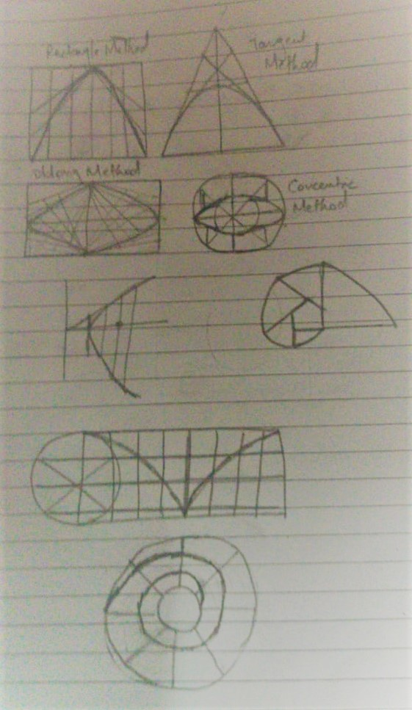

# Fig. Free hand sketch of the solution to question #

**7.4 Drawing Procedure**:

**Step 1.**

*Draw a rectangle of dimension 100 x 70. Divide the vertical lines into 4 parts and horizontal lines into 8 parts and join all the points on horizontal line with the parallel ones and join all the points on vertical line with the midpoint of upper horizontal line and with the help of spline command draw a line through the intersection points of the lines previously drawn.*

**Step 2.**

*Draw a line AC of 100mm and from the midpoint of the line draw another line BD of 160mm perpendicularly and join B with A and C. Now, divide AB and BC into 6 parts each and join the first point of AB with the last point of BC and so on. Now, with help spline command draw a line tangentially to the intersecting points starting from A and ending at C.*

**Step 3.**

*Draw a rectangle ABCD of dimension 150 x 70 and divide it into 4 quadrants. Divide the vertical and horizontal line of the first quadrant into 5 parts each and name them 1,2...and 1’,2’... Now, join 1’,2’... with E and from the point F draw a line which intersect 1’E , 2’E… passing through point 4,3… resp. and by using the mirror command do the same in all the other three quadrants and with the help of spline command draw a line through all the intersecting point to get an ellipse.*

**Step 4.**

*Draw two circles of diameter 150mm and 70mm with the same point as centre and draw the diameter for the bigger circle and with the help of polar array command copy the line in the circular form. Now, draw two lines perpendicular to each other from the circumference inside the bigger circle and outside the small circle making the diameter line as hypotenuse. Do this to two lines and then use the mirror command for the others and with the help of spline command draw a line, joining all the intersecting points of the two lines drawn.*

**Step 5.**

*Draw two lines Directrix and Axis perpendicular to each other with C as the intersection point. Mark a point F 50mm apart from C on the axis. Divide CF into 5 parts and mark 2nd point from C as V. Now, draw a line perpendicular to the axis from V of length same as VF and mark it as E. Join EC and extend it. Now, draw the lines from the other points and make them intersect the extended EC line. Now take these lines as radius and F as the centre draw arc on the both side of the axis line and with the help of spline command join all the arcs and we will get a hyperbola.*

**Step 6.**

*Draw a circle of radius 60mm and a line from the base of the circle of length 188.4mm. Now, divide the circle and the baseline into 8 equal parts. Then project the lines from the equal divisions parallel to the baseline also known as height lines and also from the centre and mark them 1’,2’,3’ etc. and from these points as centre draw circles of same diameter as before and mark the point where it intersects with the height line and with spline join all these intersecting points.*

**Step 7.**

*Draw the base pentagon of side 30mm. Take any side of the pentagon as radius and draw a circle and extend the adjacent side of the pentagon till it intersects the circumference of the circle and trim the outer circle. Now, take the extended line as the radius and repeat the previous process and repeat this process till it is completed for all the five sides and the circular like curve is the required curve.*

**Step 8.**

*Draw two circles of radius 10mm and 70mm with the same point as the centre and with the help of a polar array divide it into 8 equal parts and trim out the lines from the inner circle. Now, take any line as the baseline and divide it into 12 parts and take the distance of the centre and points as radius draw arcs on the lines correspondingly. Now, using the spline command from the intersection of the baseline and the circumference of the inner circle, start joining the other intersecting points of the arc and the line and then the curve formed is the required Archemedian spiral*.

1. **Commands used**:

|  |  |  |
| --- | --- | --- |
| **Sr. No.** | **Command** | **Use** |
| 1. | ***UNITS*** | *Used to set unit type and precision.* |
| 2. | ***LIMITS*** | *Define the workspace and give it a boundary.* |
| 3. | ***STYLE*** | *Help us to set font type, height, width etc.* |
| 4. | ***LINE*** | *Draw a line of given length.* |
| 5. | ***TEXT*** | *Used to write a text.* |
| 6. | ***CIRCLE*** | *Used to draw a circle.* |
| 7. | ***POLYGON*** | *Used to draw a polygon of n-sides.* |
| 8. | ***OFFSET*** | *Help us to copy any object at a distance of x from it.* |
| 9. | ***TRIM*** | *Used to remove any undesired line.* |
| 10. | ***POLAR ARRAY*** | *To arrange the of copies of an object in a circular form.* |
| 11. | ***MIRROR*** | *To get a mirror copy of selected objects.* |
| 12. | ***ARC*** | *To draw an arc.* |
| 13. | ***SPLINE*** | *To draw a special and continuous line.* |
| 14. | ***PEDIT*** | *To edit polylines, objects to be joined to polylines, and related objects.* |

1. **Result**:

*Thus, by the use of AutoCAD 2021 we were able to draw conic curves like parabola, ellipse, hyperbola etc and some special curves like cycloid, involute and Archmedian spiral*.

|  |  |  |  |
| --- | --- | --- | --- |
| **Faculty Name** |  | **Date of Submission** |  |
| **Signature** |  | **Marks** |  |